
Lab Program Number: 32 Date: 19th March,2026
Title: Configuring SSH server to allow/deny root login & allow/deny user login.

- Install required package for OpenSSH server.
Command:
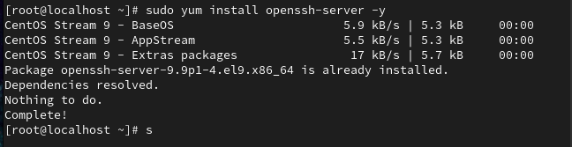
Output:
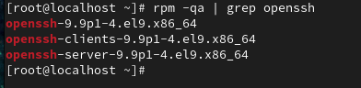

- Allow ssh packets to enter through the firewall.
Command:
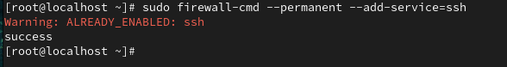
Output:
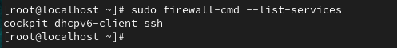

- Start & enable ssh service.
Command:
Output:
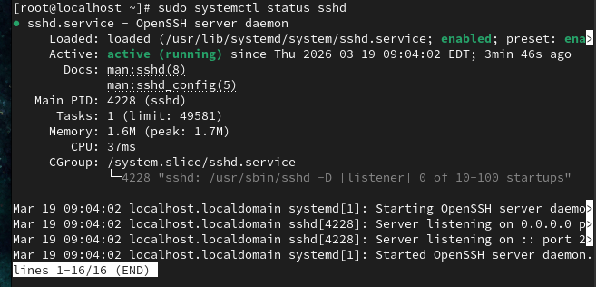

- Configure SSH server to deny direct root login.
Command:
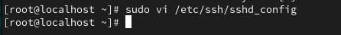
Finding and changing the PermitRootLogin: no
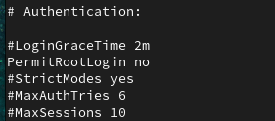
Restart SSH Server:
Output:
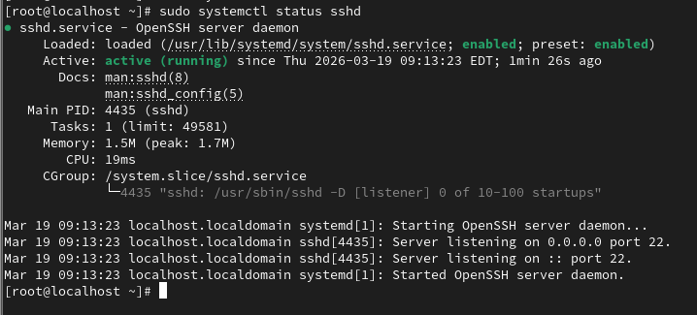

- Configure OpenSSH server to block login from user.
Command:
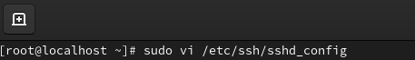
Adding to bottom:
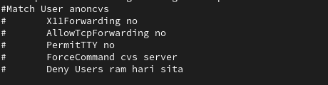

Restart Server:
Output:
